**UNIX - OPERATING SYSTEM**

**----- (ARUN SIR) ADAPA GANESH**

**Today(01/09/2020):**

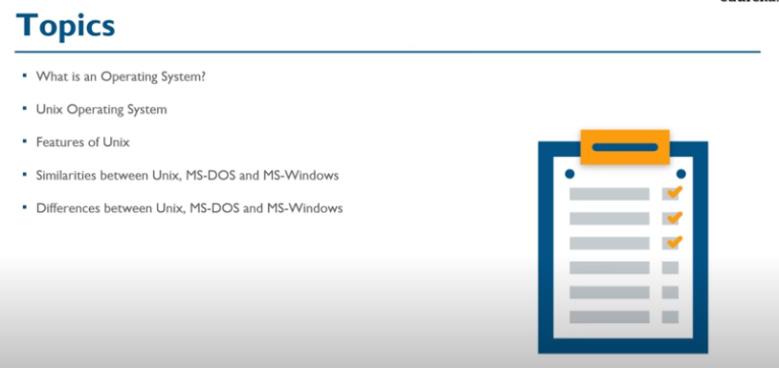

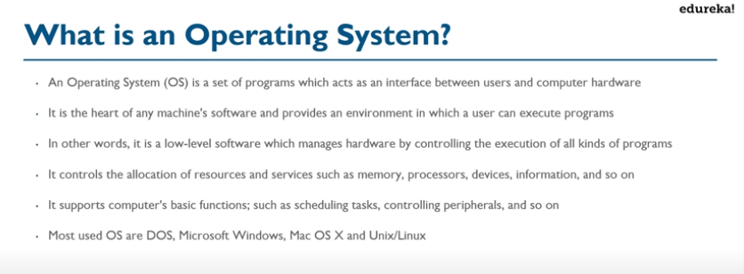

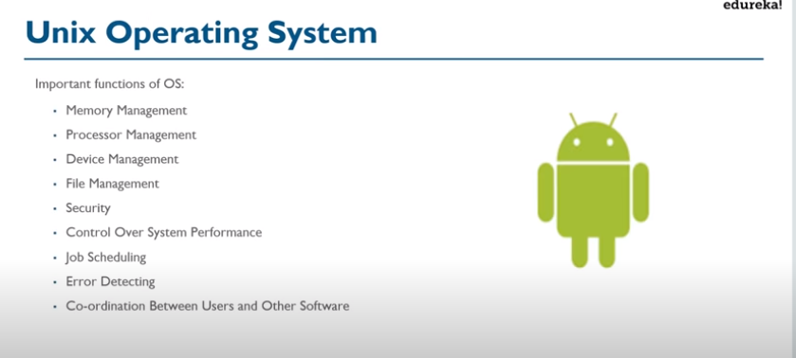

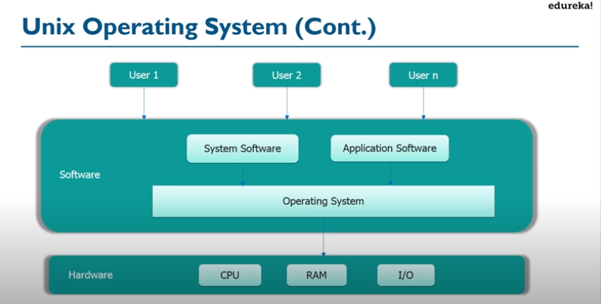

American Telephone & Telegraph Company

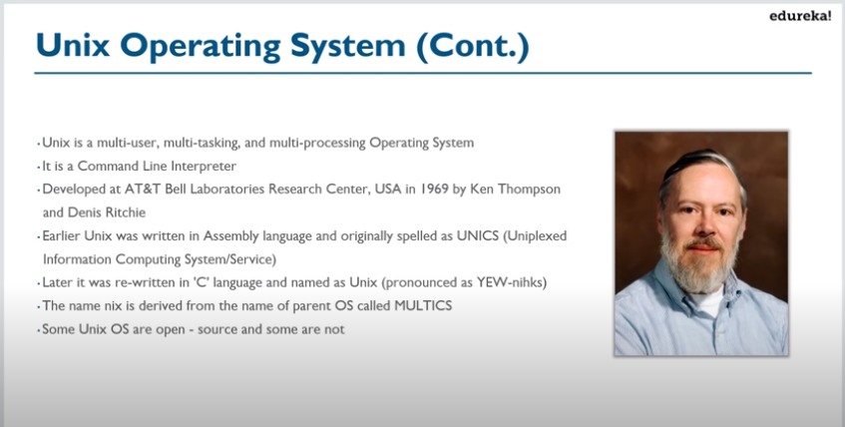

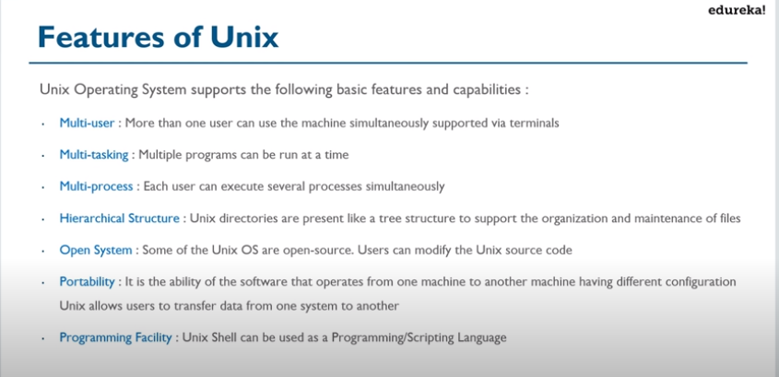

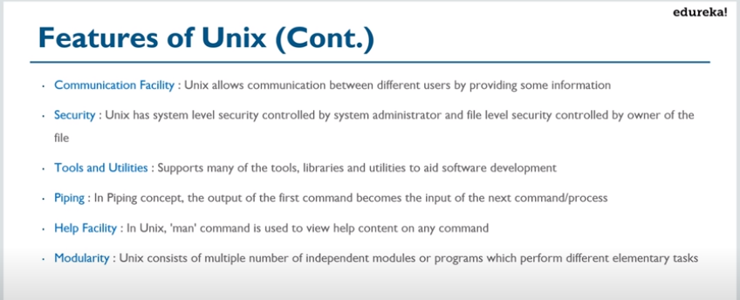

**DOS:**DOS (Disk Operating System) are simple text command operating systems that were popular from 1981 to 1995.DOS used a text based interface that required text and codes to operate.Text is used as the basic input system commands.DOS is unable to run multiple processes at the same time.The highest amount of storage size available is 2GB.Booting up system is DOS is less demanding on the CPU.DOS uses a directory system, where all the files are contained within a particular directory or a subdirectory.More ideally used for prototyping, testing, and making automated systems.DOS is free.

**Windows:**Windows is a range of graphical interface operating systems that are developed and sold by Microsoft.Windows uses graphics, images and text.Uses a mouse for all operating system input.Windows is a multitasking operating system; allowing more than one process to work simultaneously.Window systems offer storage space up to 2 terabyte.Booting up Windows is more demanding on the CPU.Windows uses a different registry compared to DOS, making it difficult to manually delete programs. An excessive number of temporary files and file fragments can cause the system to slow down or crash.Used worldwide as the most popular operating system.Windows is costly.

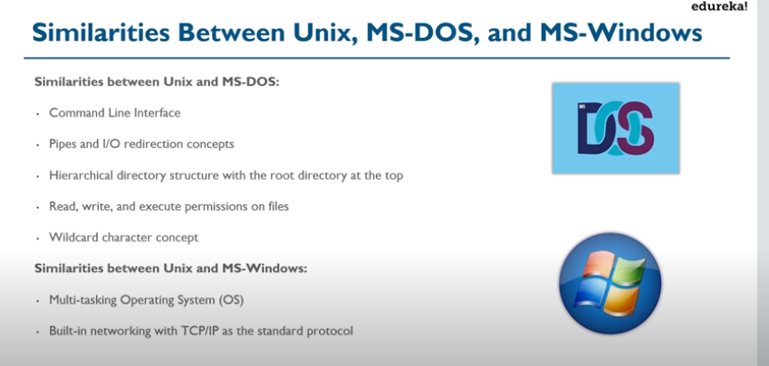

TCP works at the Transport Layer or Layer 4. This Layer is responsible for mainly guaranteed end to end delivery and error correction. Before they can do this though, they need to know where to go.

IP works at the Network Layer or Layer 3. This Layer is responsible for mainly determining the best path to get from Host A to Host B and detecting and rerouting traffic around any failures.

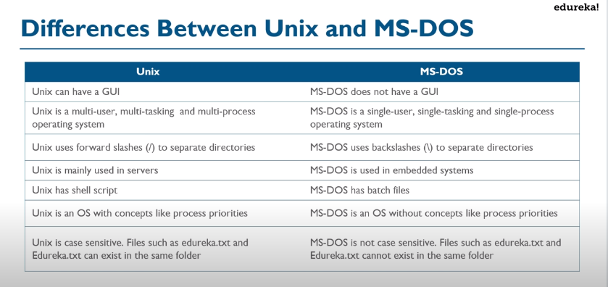

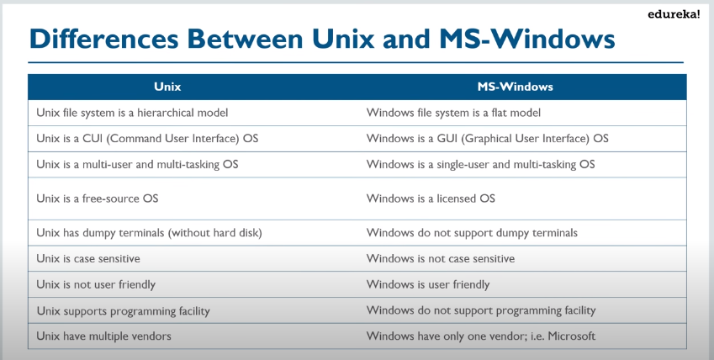

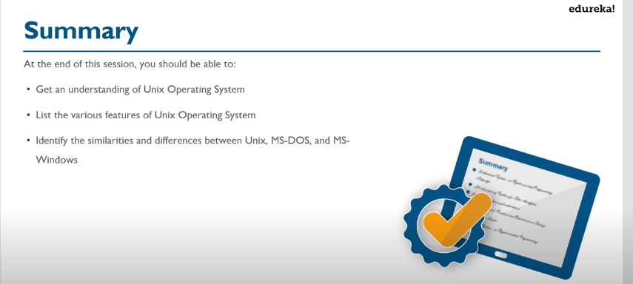

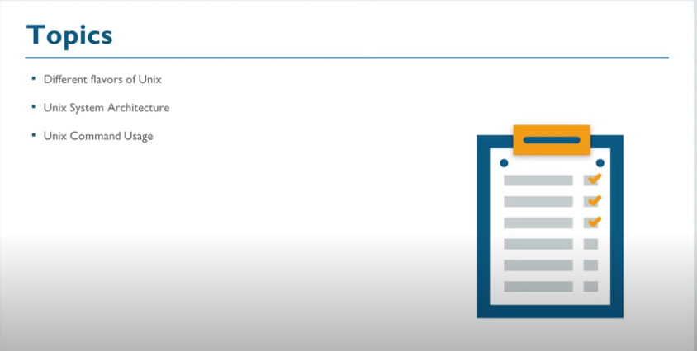S

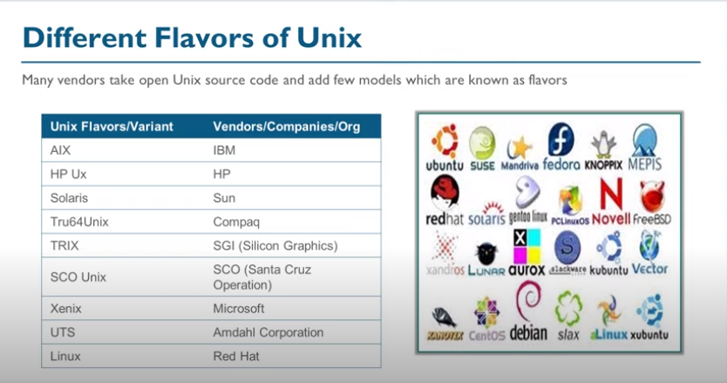

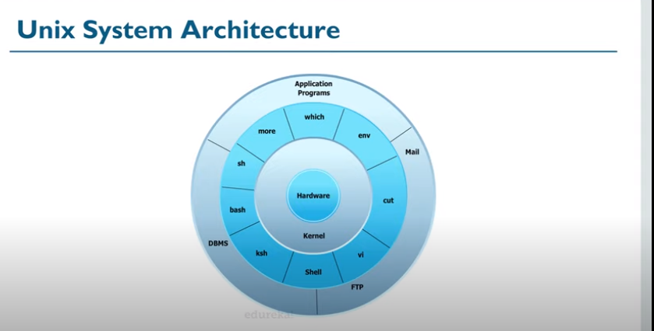

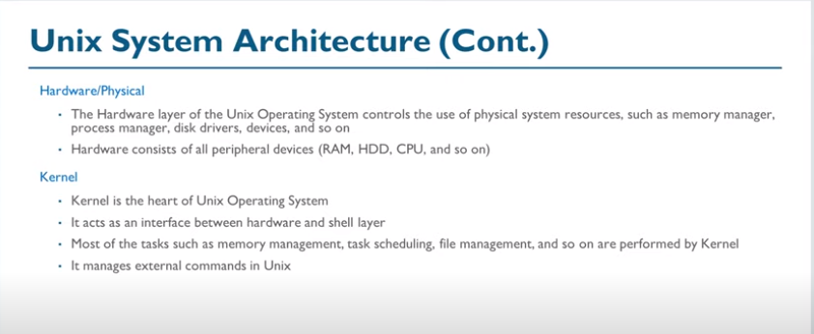

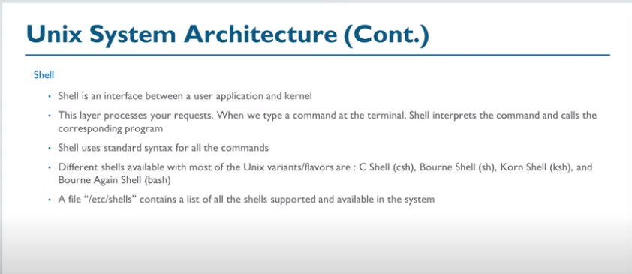

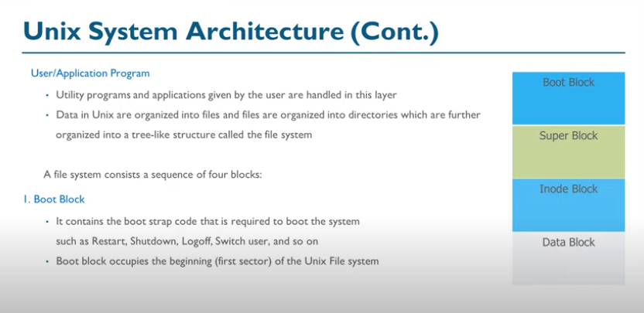

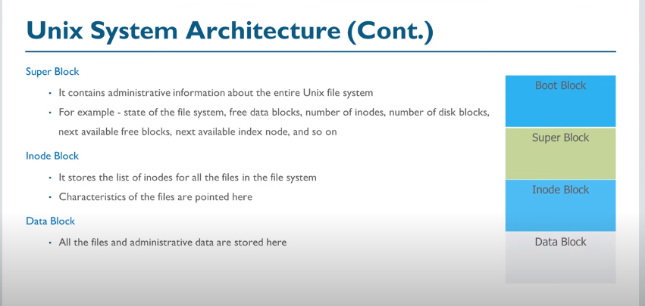

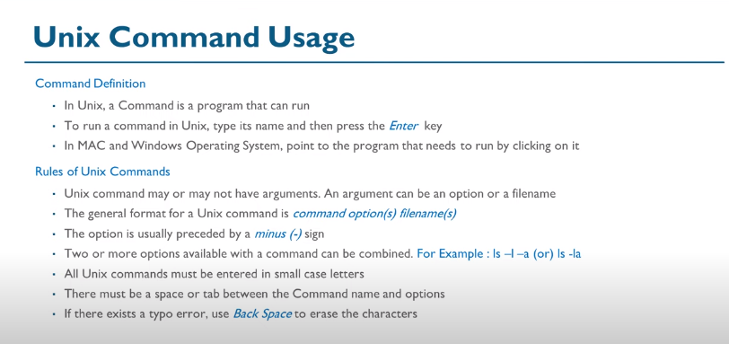

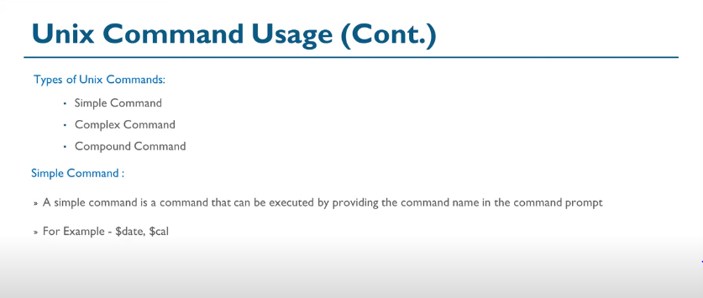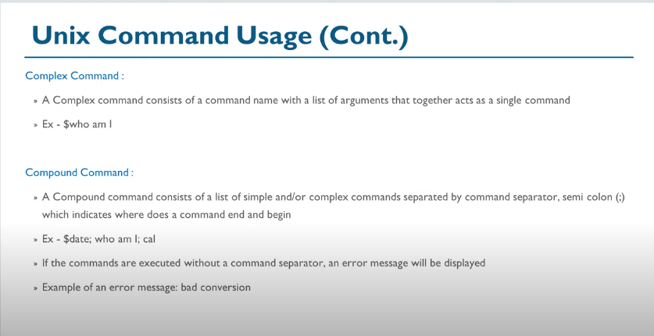

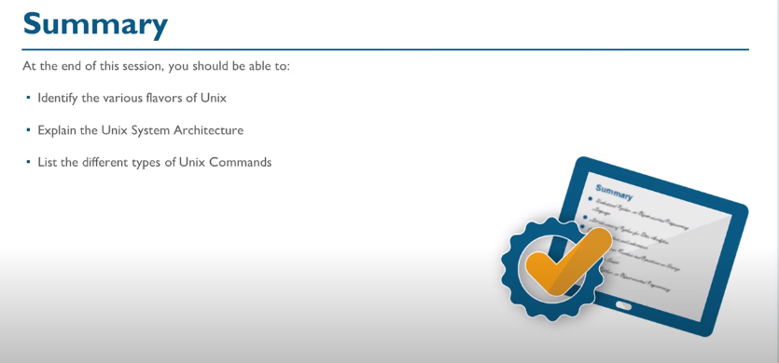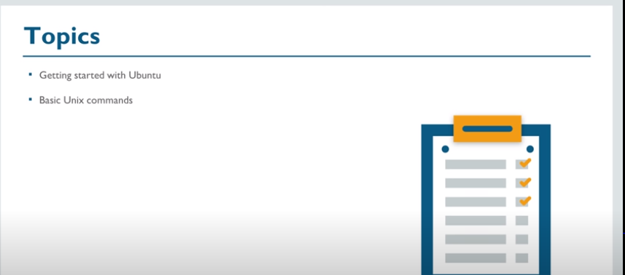

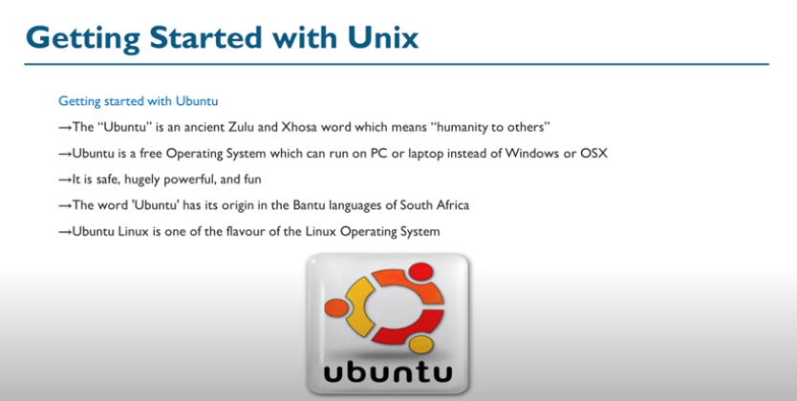

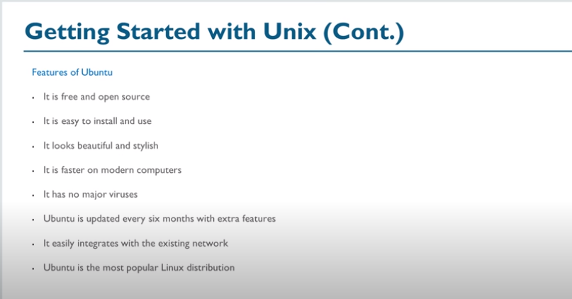

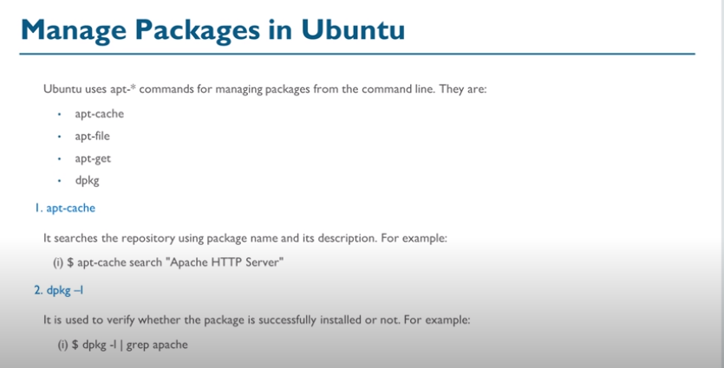

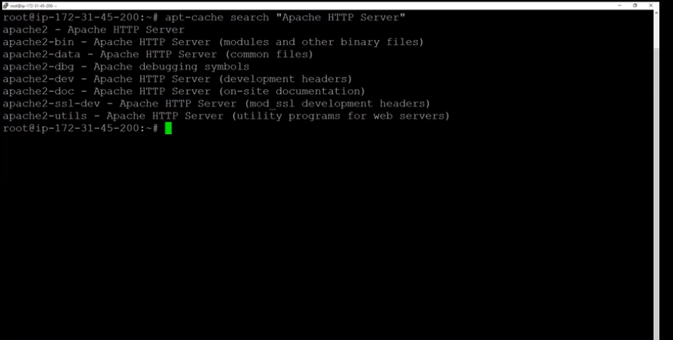

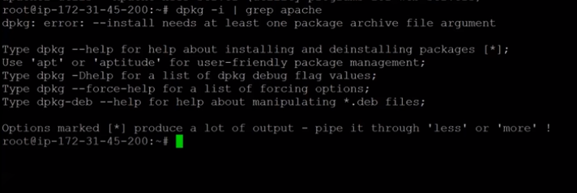

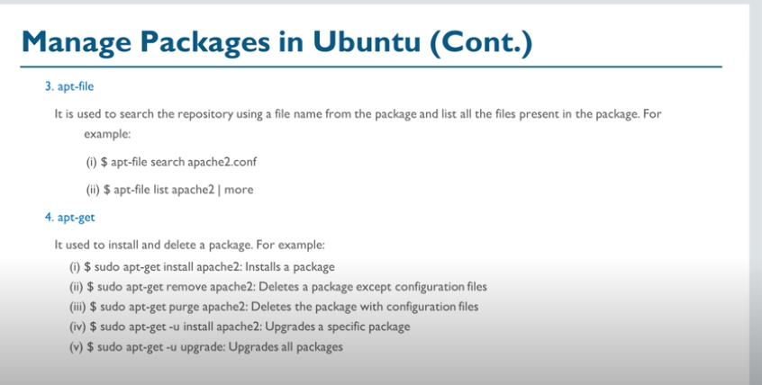

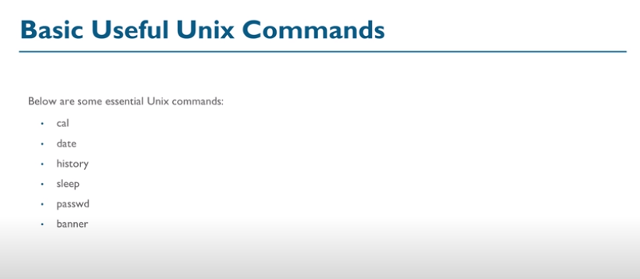

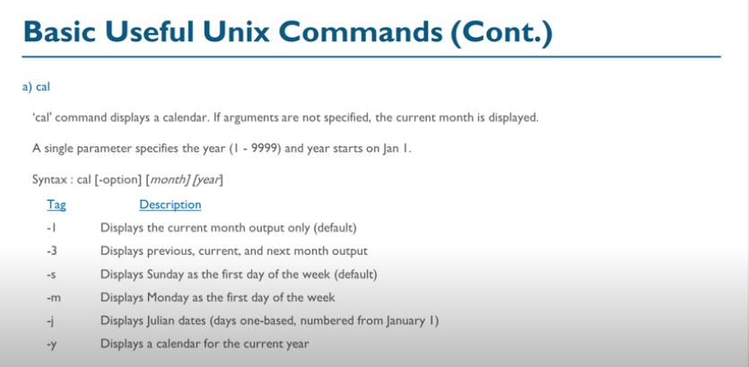

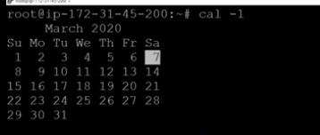

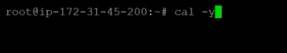

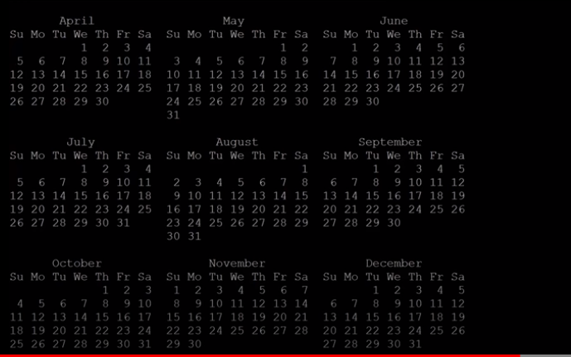

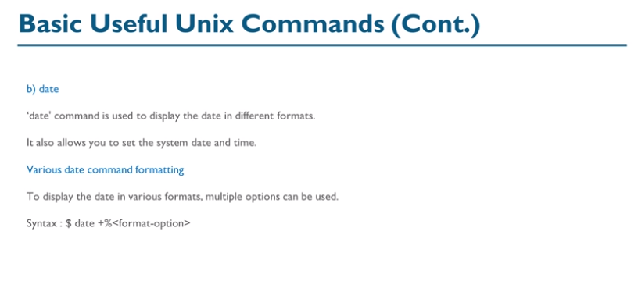

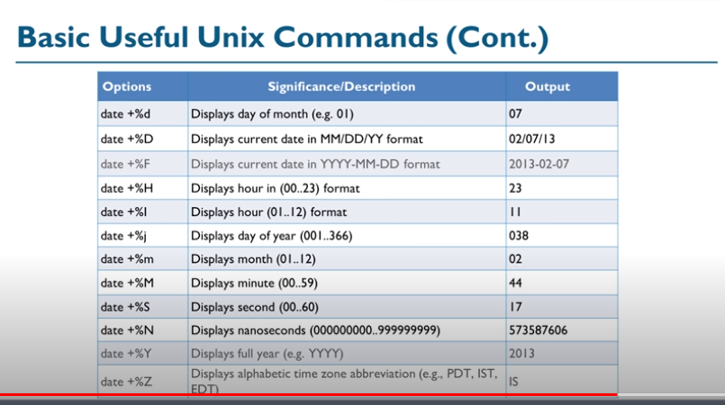

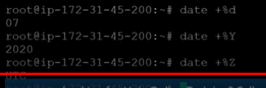

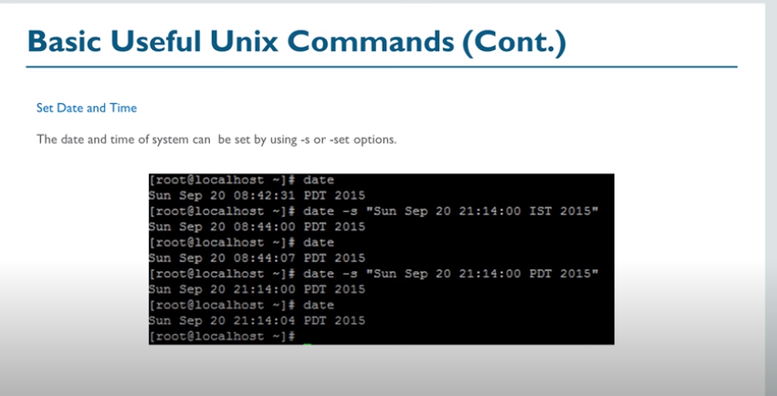

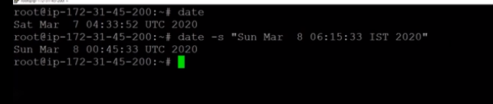

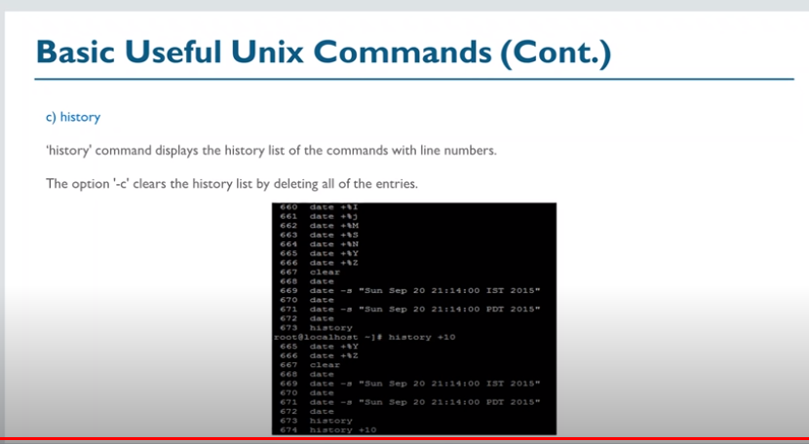

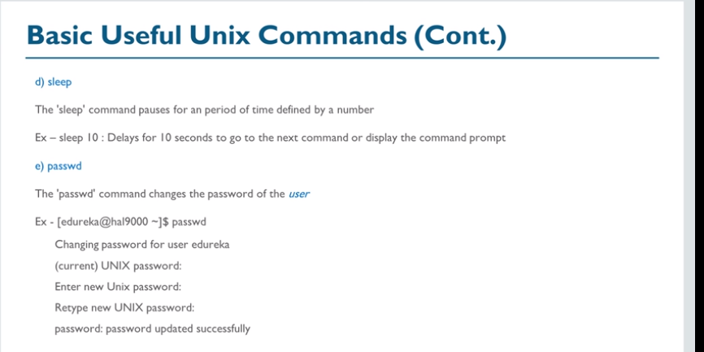

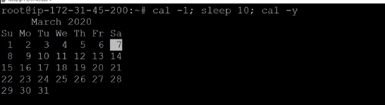

After 10 secconds sleep,

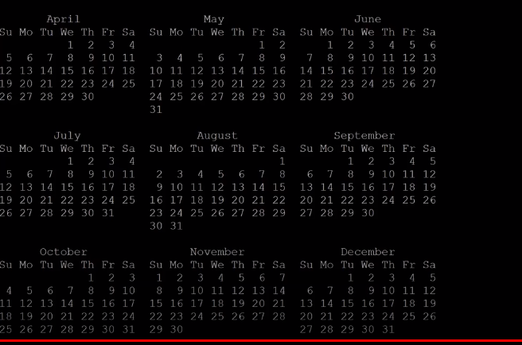

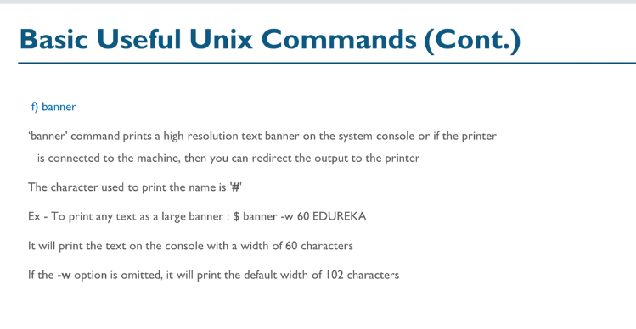

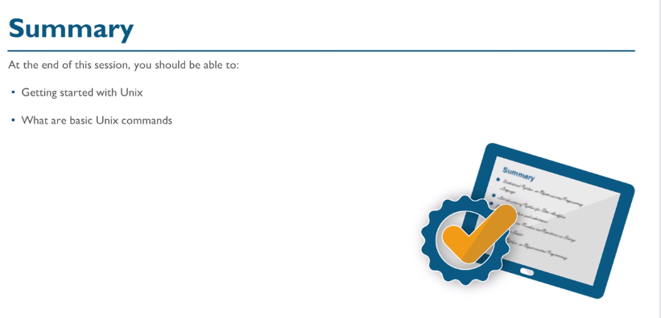



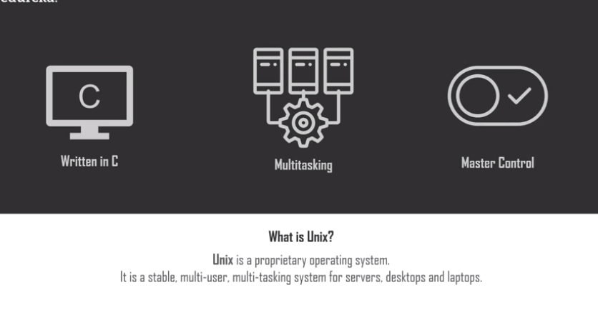

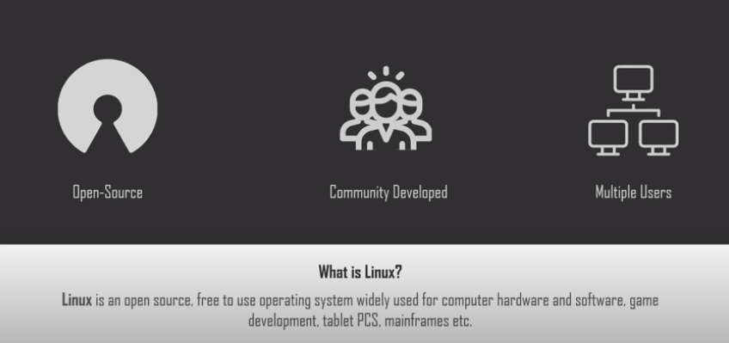

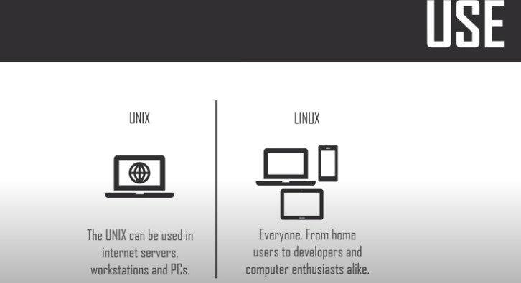

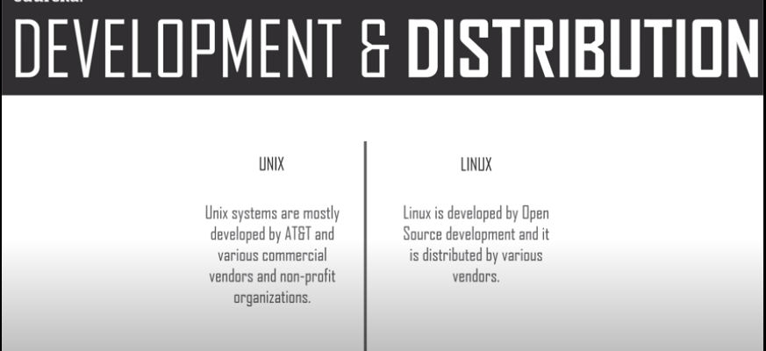

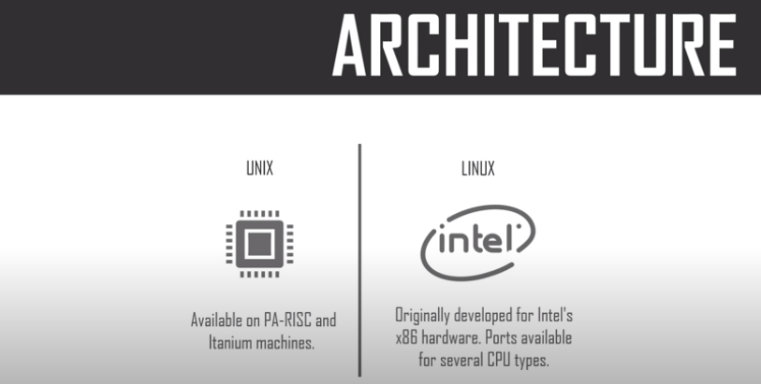

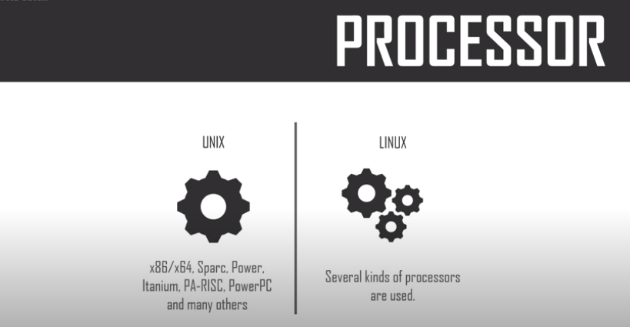

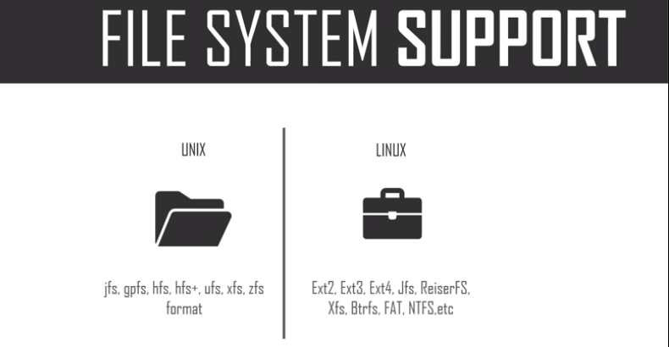

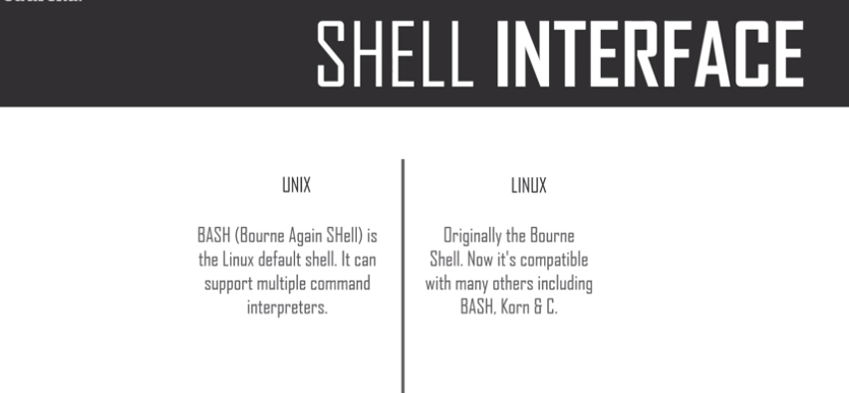

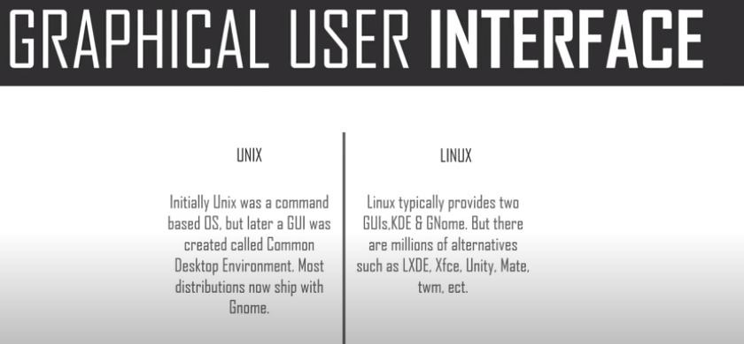

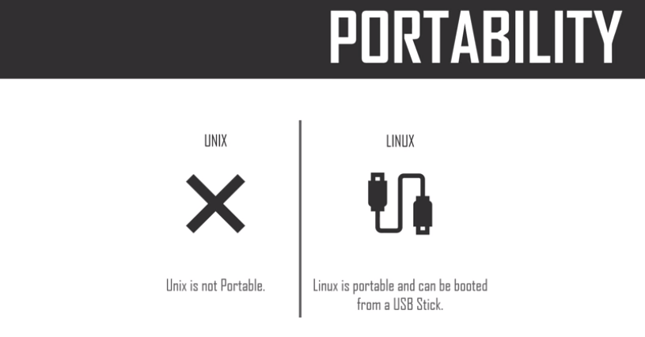

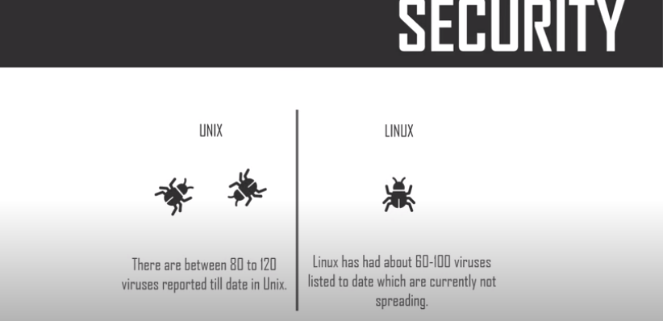

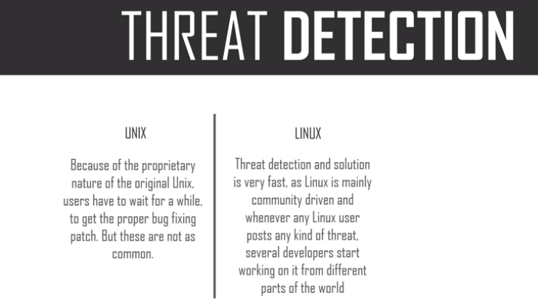

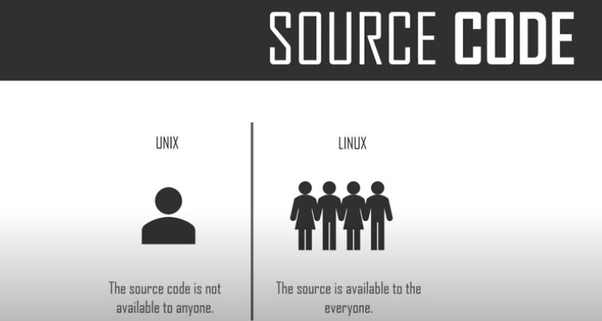

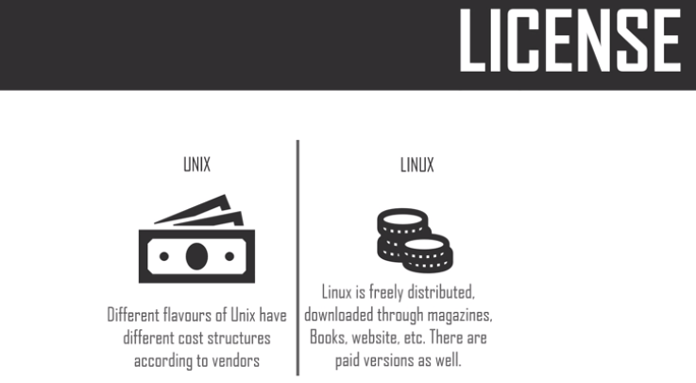

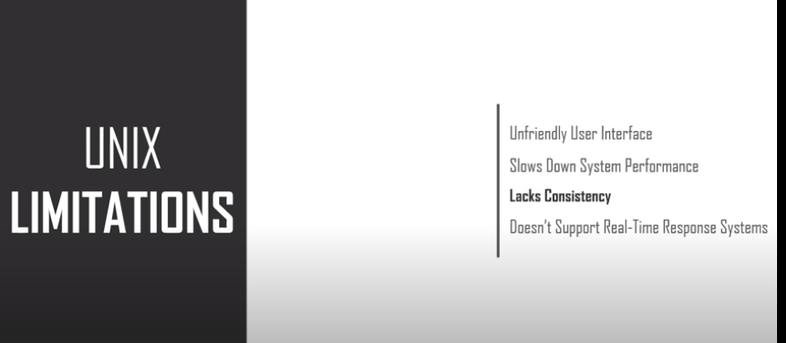

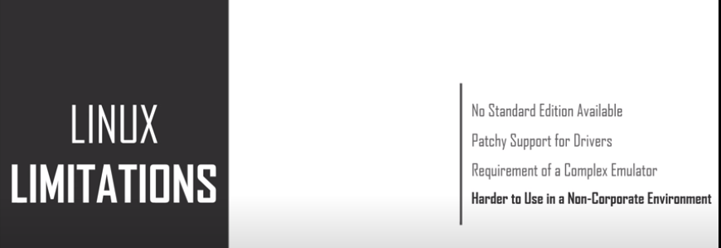



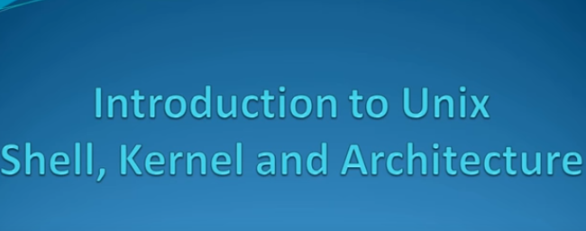

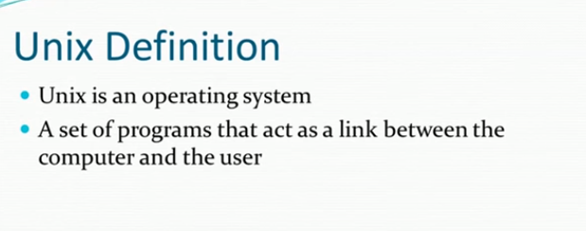

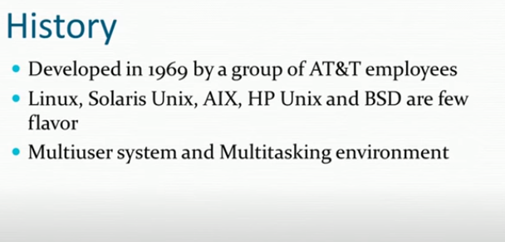

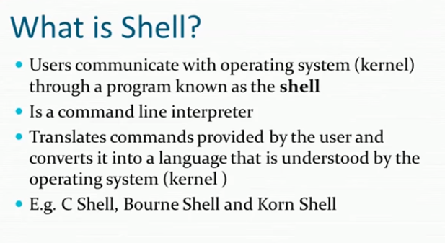

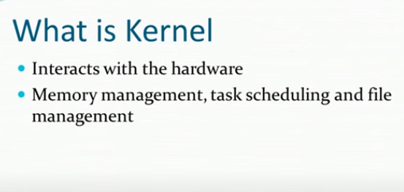

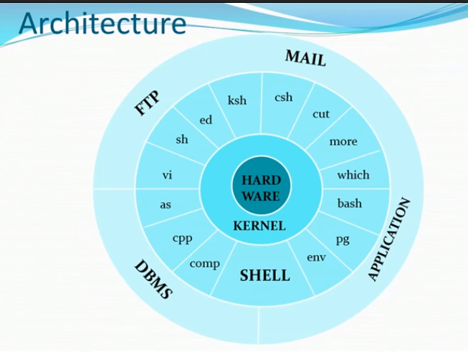

**Today(03/09/2020):**

**Unix:**

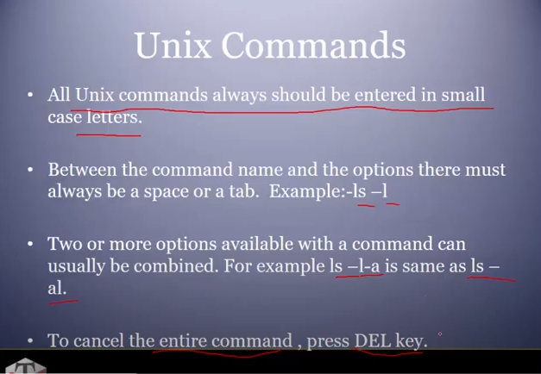

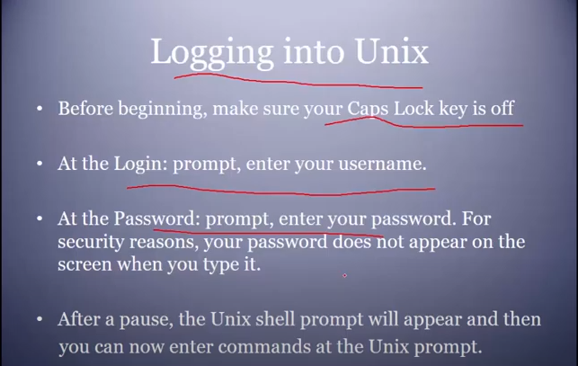

**Cal command:**

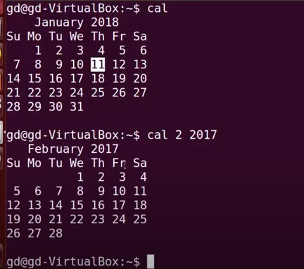

Date command:

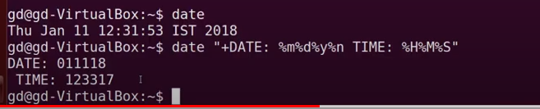

Who command:

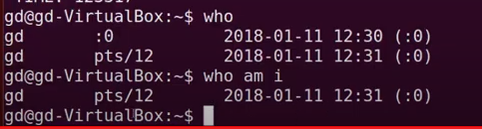

Passwd command:

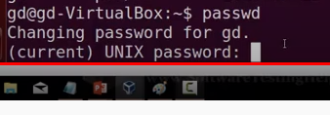

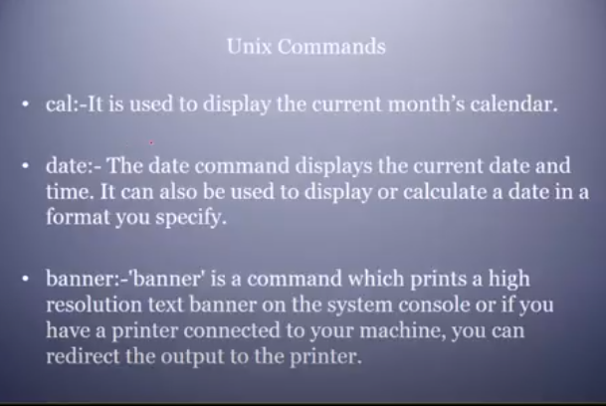

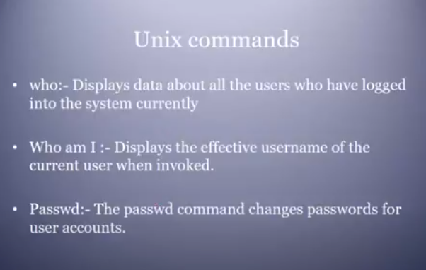

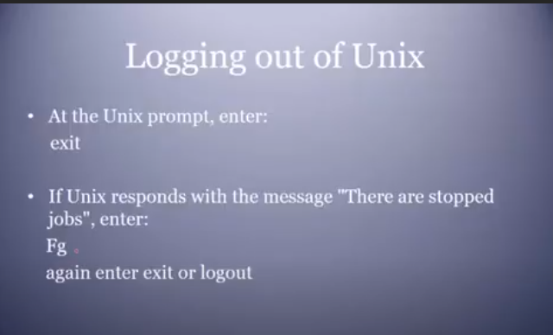

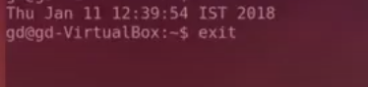

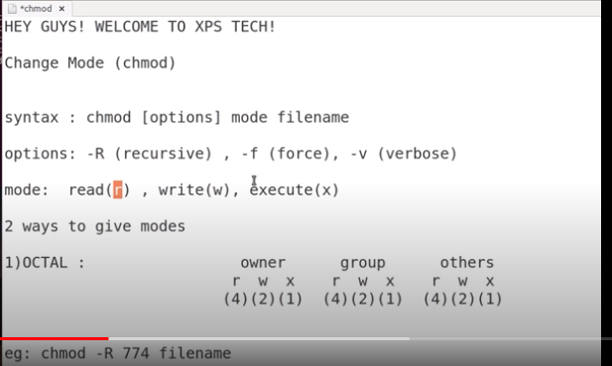

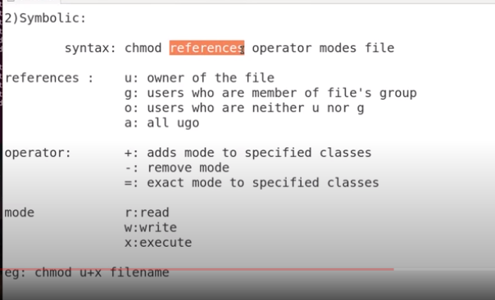

Important: Executed by Ganesh.

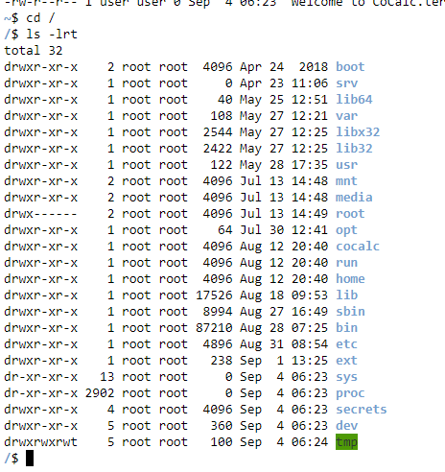

Remove : rm command

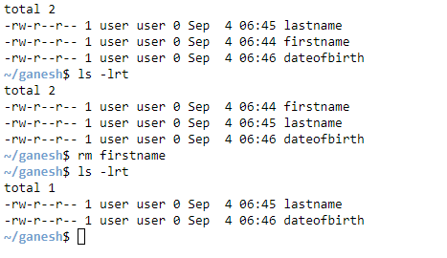

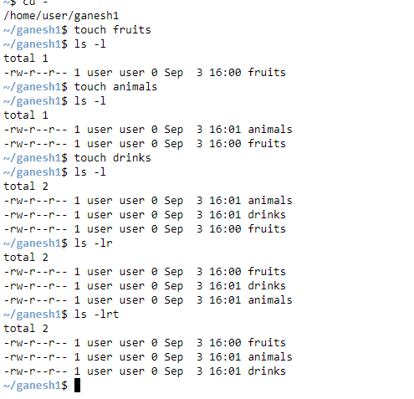

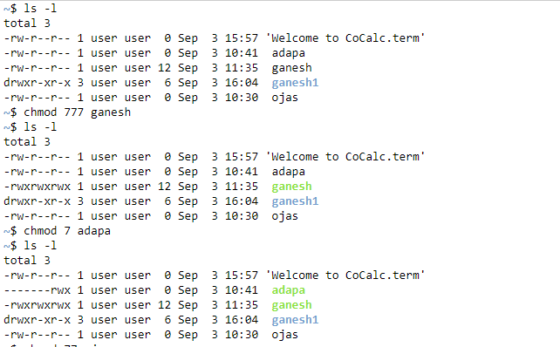

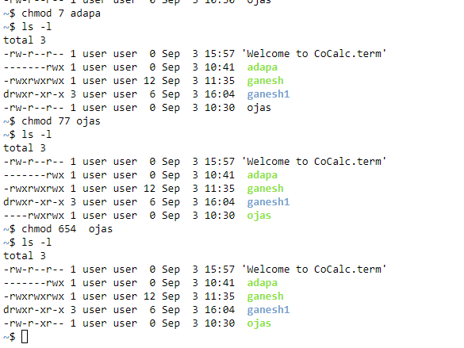

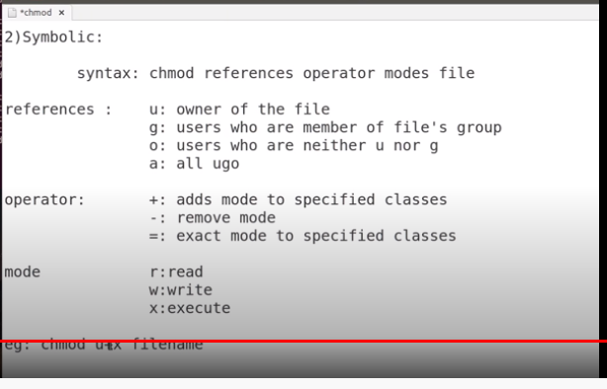

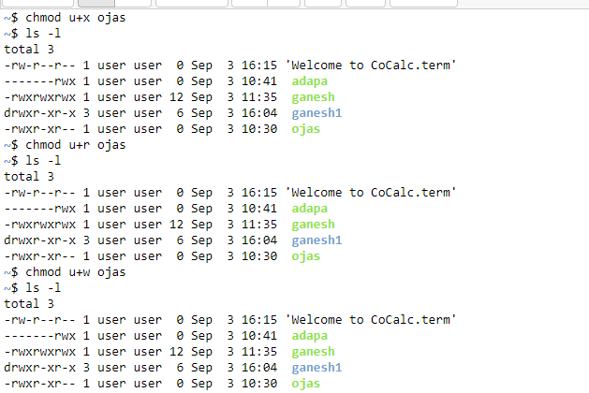

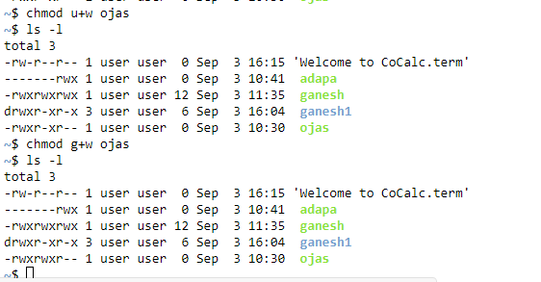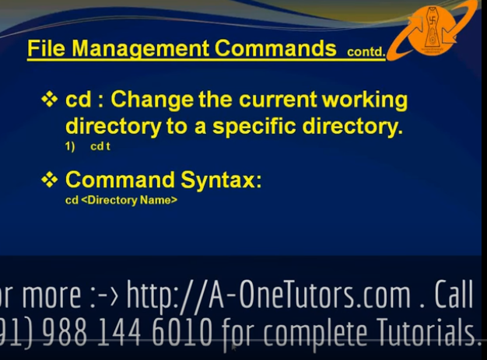

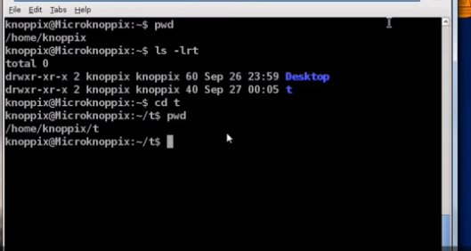

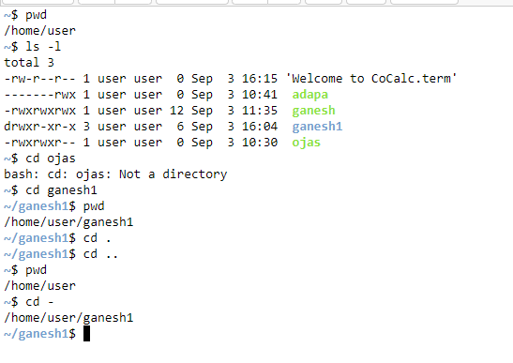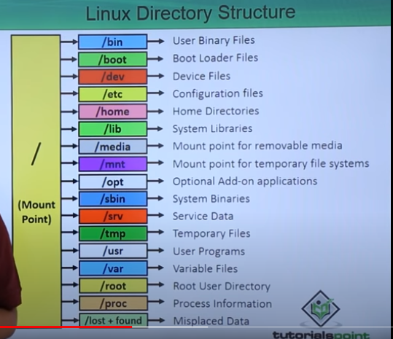

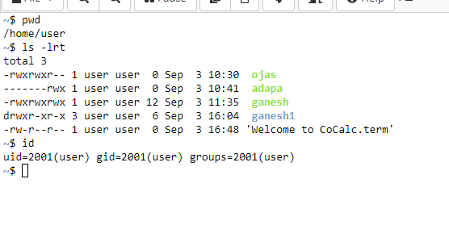

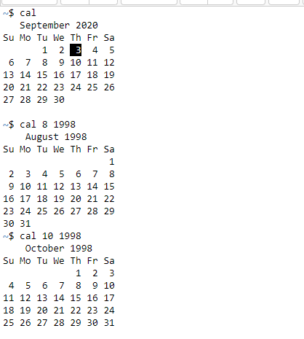

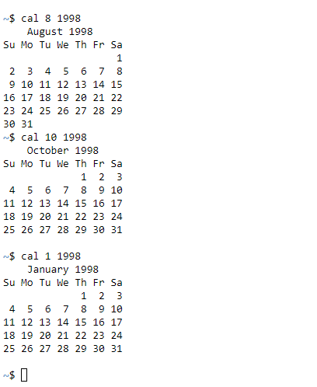

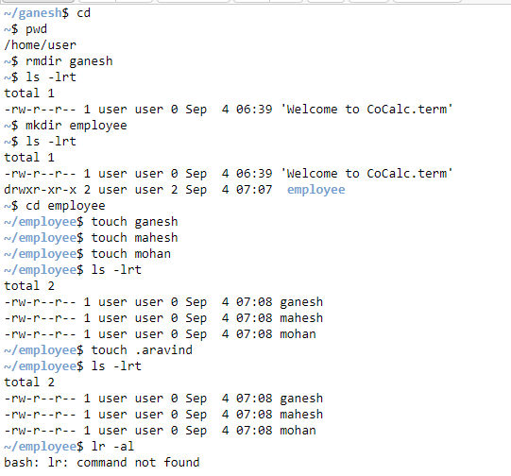

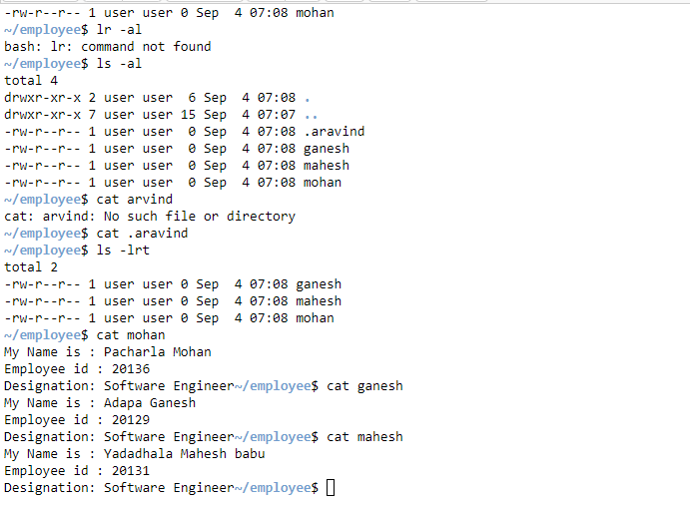

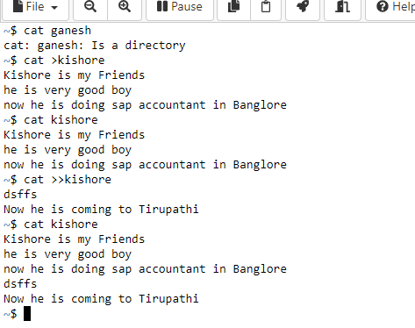

**Today(04/09/2020):**

**Umask:**

The **umask** (**UNIX** shorthand for "user file-creation mode mask") is a four-digit octal number that **UNIX** uses to determine the file permission for newly created files. Every process has its own **umask**, inherited from its parent process.

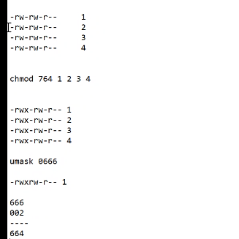

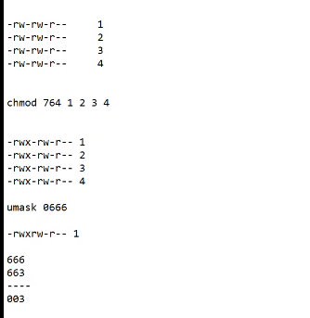

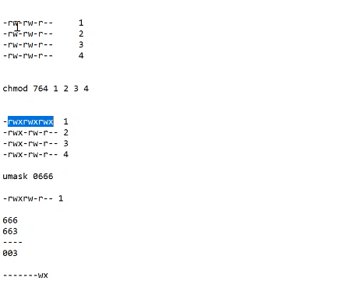

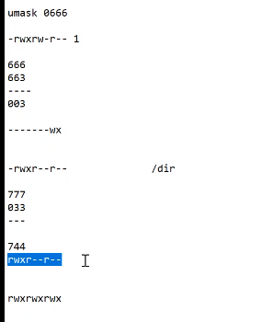

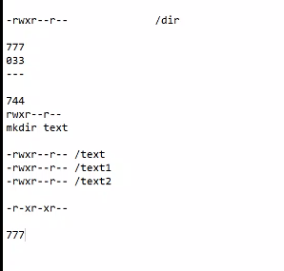

Finally

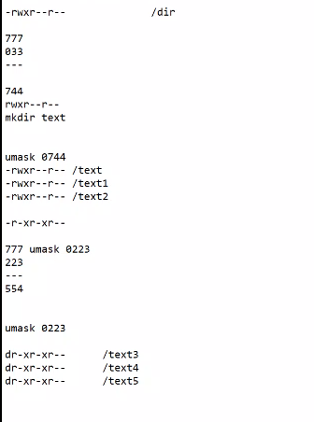

Umask:

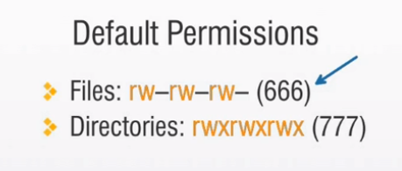

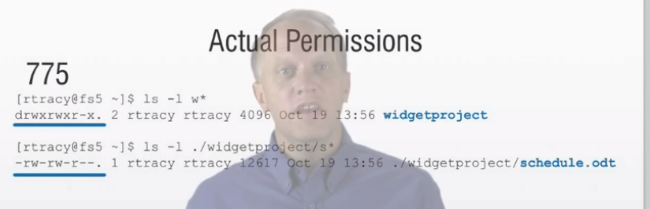

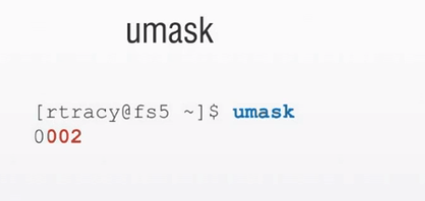

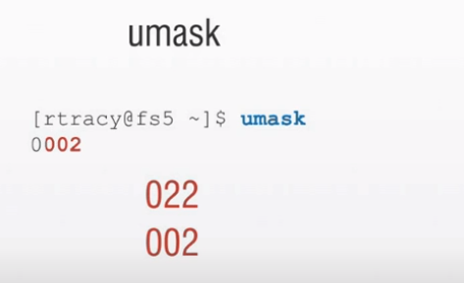

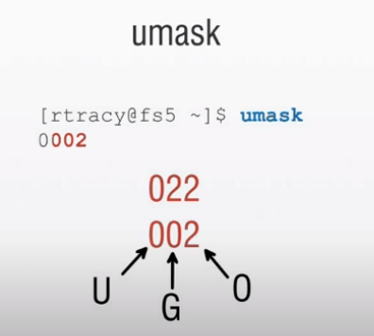

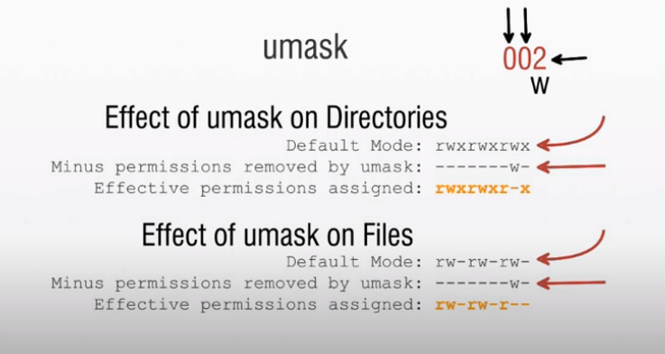

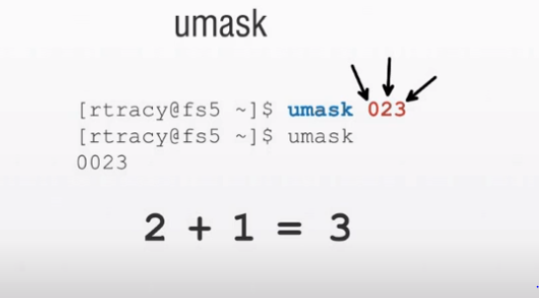

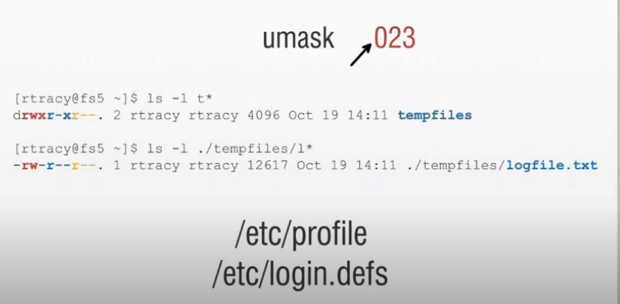

Login Process In Unix:

## The Login Process

The following step-by-step description shows what happens each time a user logs in to a UNIX computer system.

1. Users enters their username.
2. User enters their password.
3. The operating system confirms your name and password.
4. A "shell" is created for you based on your entry in the "/etc/passwd" file (in small businesses, this is usually a Bourne Shell).
5. You are "placed" in your "home"directory.
6. Startup information is read from the file named "/etc/profile". This file is known as the system login file. When every user logs in, they read the information in this file.
7. Additional information is read from the file named ".profile" that is located in your "home" directory. This file is known as your personal login file. (This is the file that usually contains the "menu" program.)

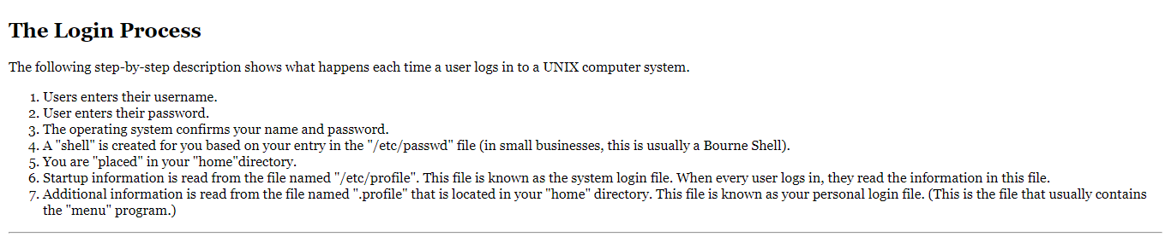

# Exercise: Examining the "login" files.

|  |  |  |
| --- | --- | --- |
| Step | You Type ... | Comments/Prompts |
| 1 | more /etc/profile | This will display the first system startup file that is read when you log in.With the "more" command, you can use the <spacebar> to view the next page, the <Enter> key to view one more line, or type "q" to quit. |
| 2 | more .profile | This will display your personal startup file. |
| 3 | more /etc/passwd | This will display the systems "password" file. |
| 4 | grep 'root' /etc/passwd | "grep" can be thought of as search. It lets you search for text within files. This command searches for the text string "root" within the file named "/etc/passwd". |

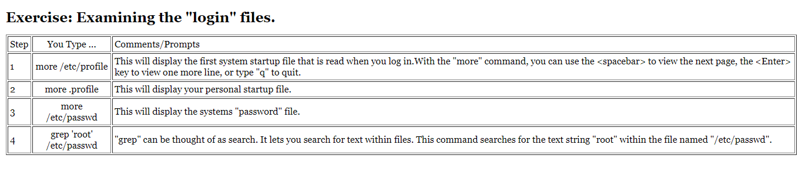

**Today(05/09/2020):**

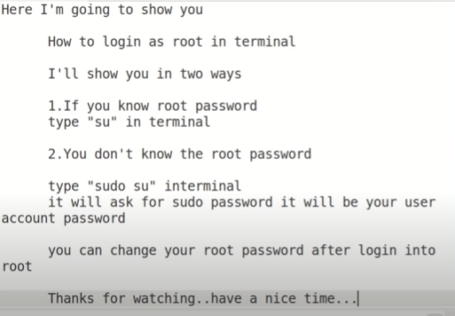

Mv command:

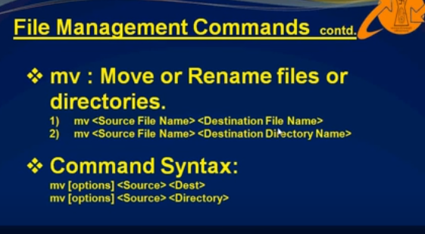

Rename Execution:

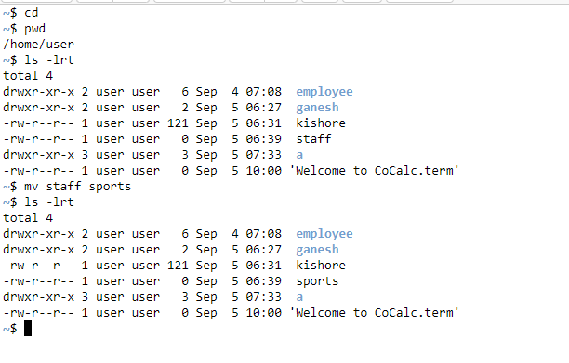

**Moving files to a directory :**

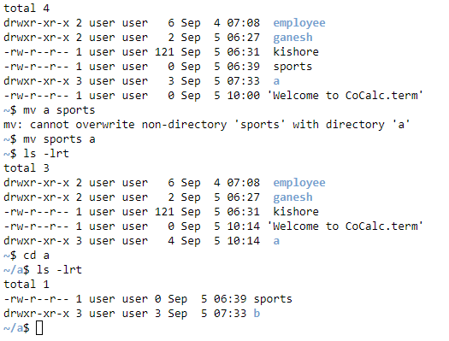

Copy Command in Unix as cp:

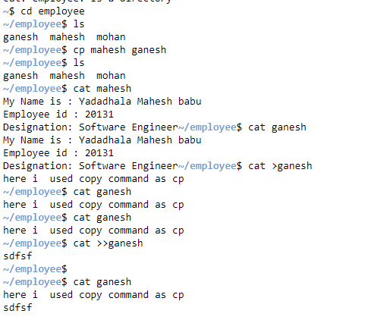

L**ogin Process in Unix:**

**Process :**

A ****process**** refers to a program in execution; it’s a running instance of a program. It is made up of the program instruction, data read from files, other programs or input from a system user.

#### **The Init Process**

****Init**** process is the mother (parent) of all processes on the system, it’s the first program that is executed when the [Linux system boots up](https://www.tecmint.com/linux-boot-process/" \t "https://www.tecmint.com/linux-process-management/_blank); it manages all other processes on the system. It is started by the kernel itself, so in principle it does not have a parent process.

The init process always has process ID of ****1****. It functions as an adoptive parent for all orphaned processes.

You can use the ****pidof command**** to find the ID of a process:

# pidof systemd

# pidof top

# pidof httpd

**[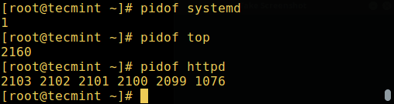](https://www.tecmint.com/wp-content/uploads/2017/03/Find-Linux-Process-ID.png)**

Actual Process:

/etc: **almost all system-wide configuration files are under /**etc**, but not all files in /**etc** are configuration files**

<https://www.linuxnix.com/how-login-process-work-in-linux/>